**Name: Setti Raviteja, Trainer: Madhukar reddy sir.**

**Course: AWS Devops, Email:** [sraviteja698@gmail.com](mailto:sraviteja698@gmail.com)

**Batch:** 12pm (112),

**2 Subnets connect to one VPC and remove internet**

**gat-way to one Subnet**

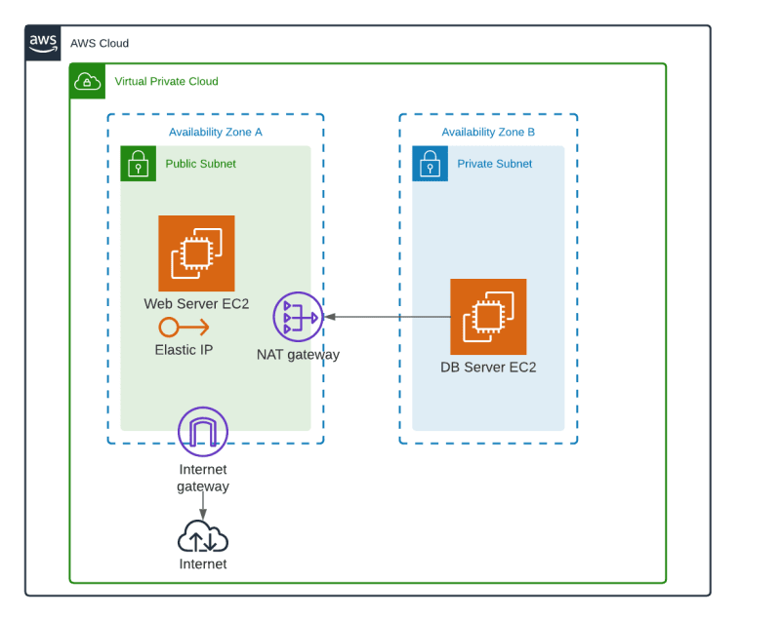

**­**

**Creating vpc:**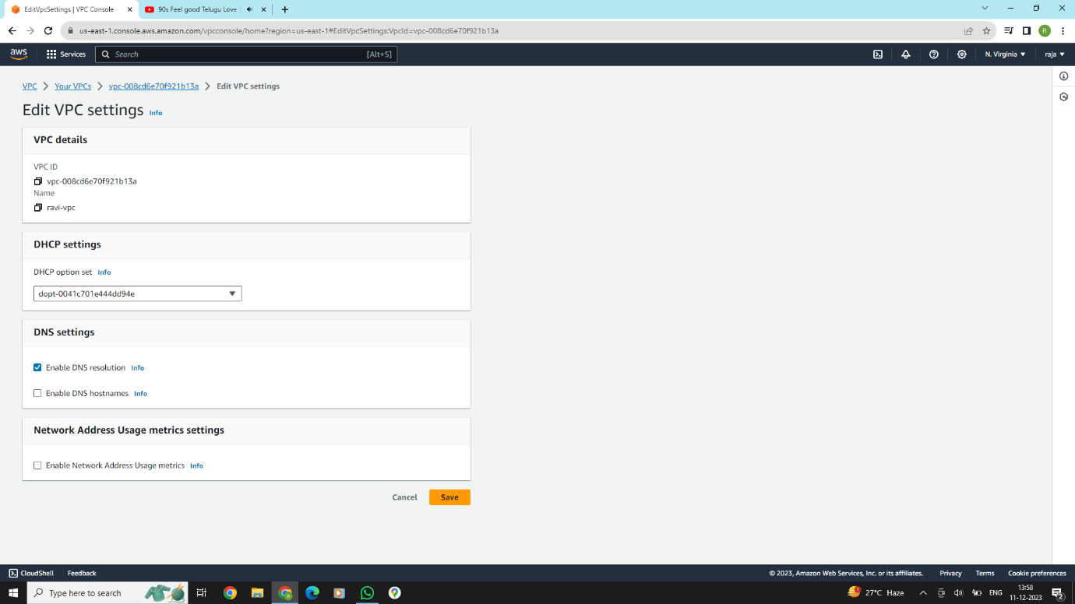

**Vpc created successfully in the bellow picture**

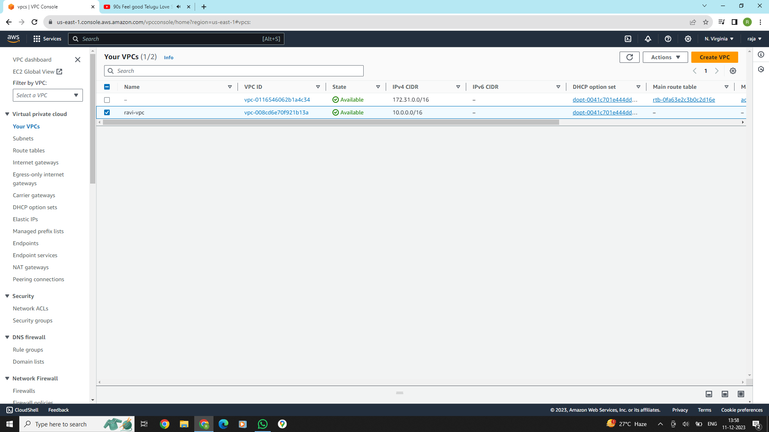

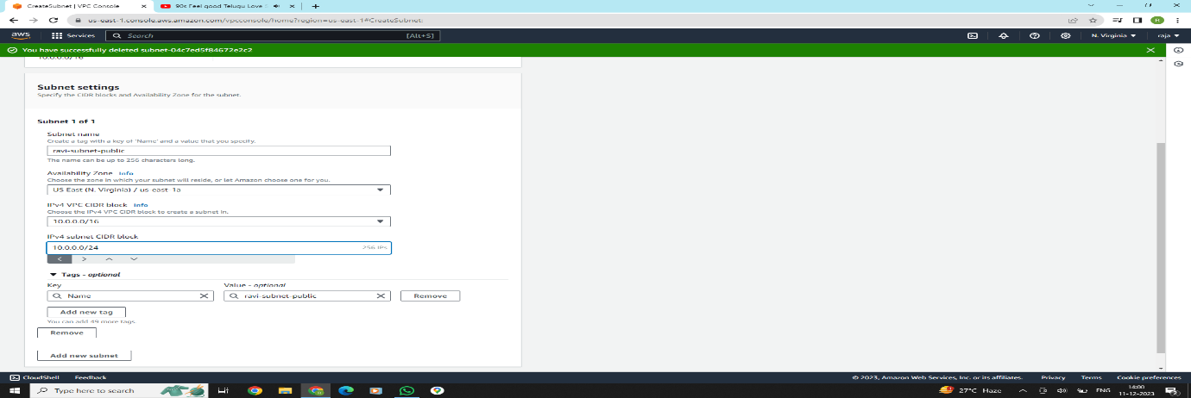 **Now we create 2 subnets for public and private instance**

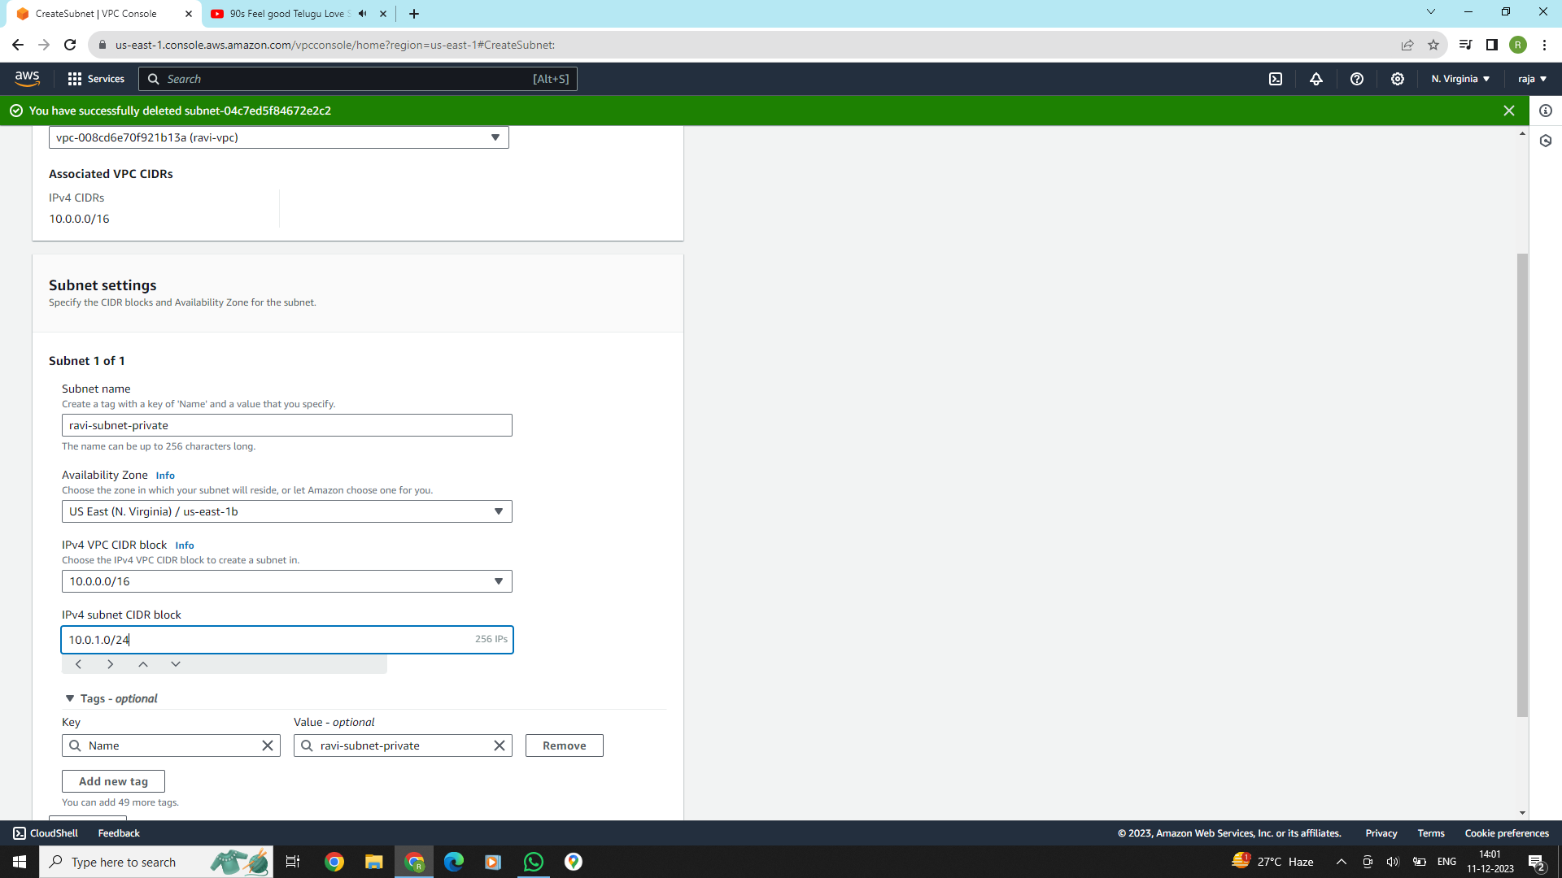

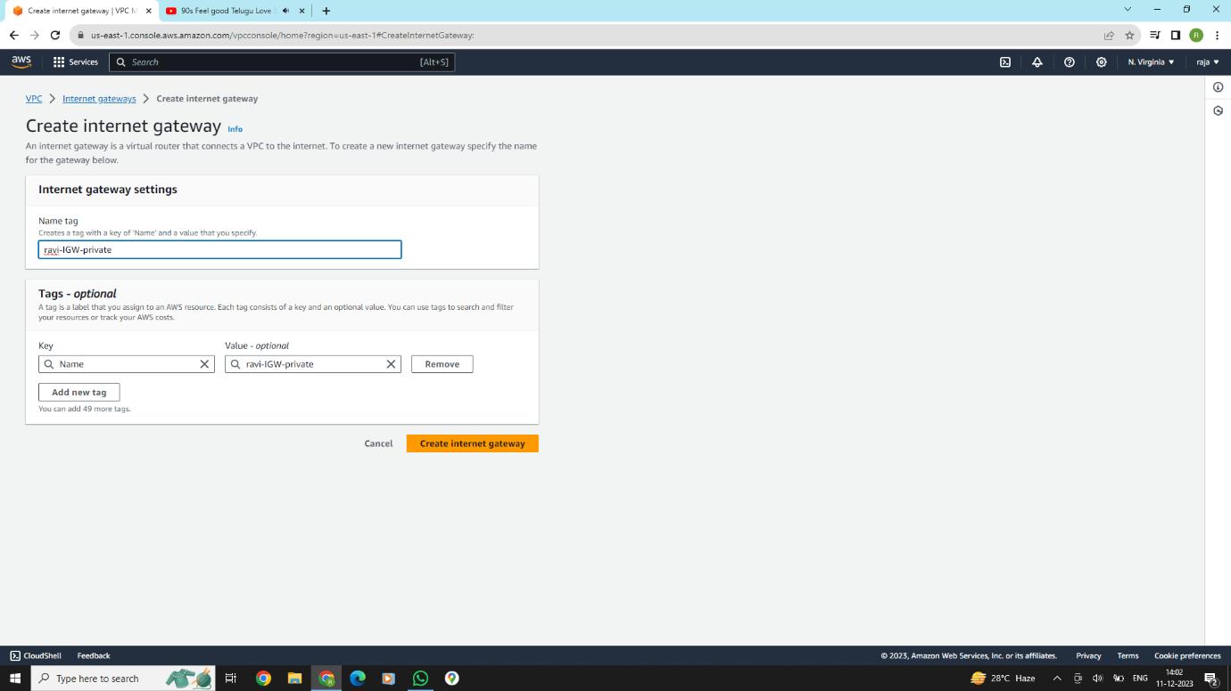**Now we need to create 2 internet gate-wayS and attach to the existing VPC**

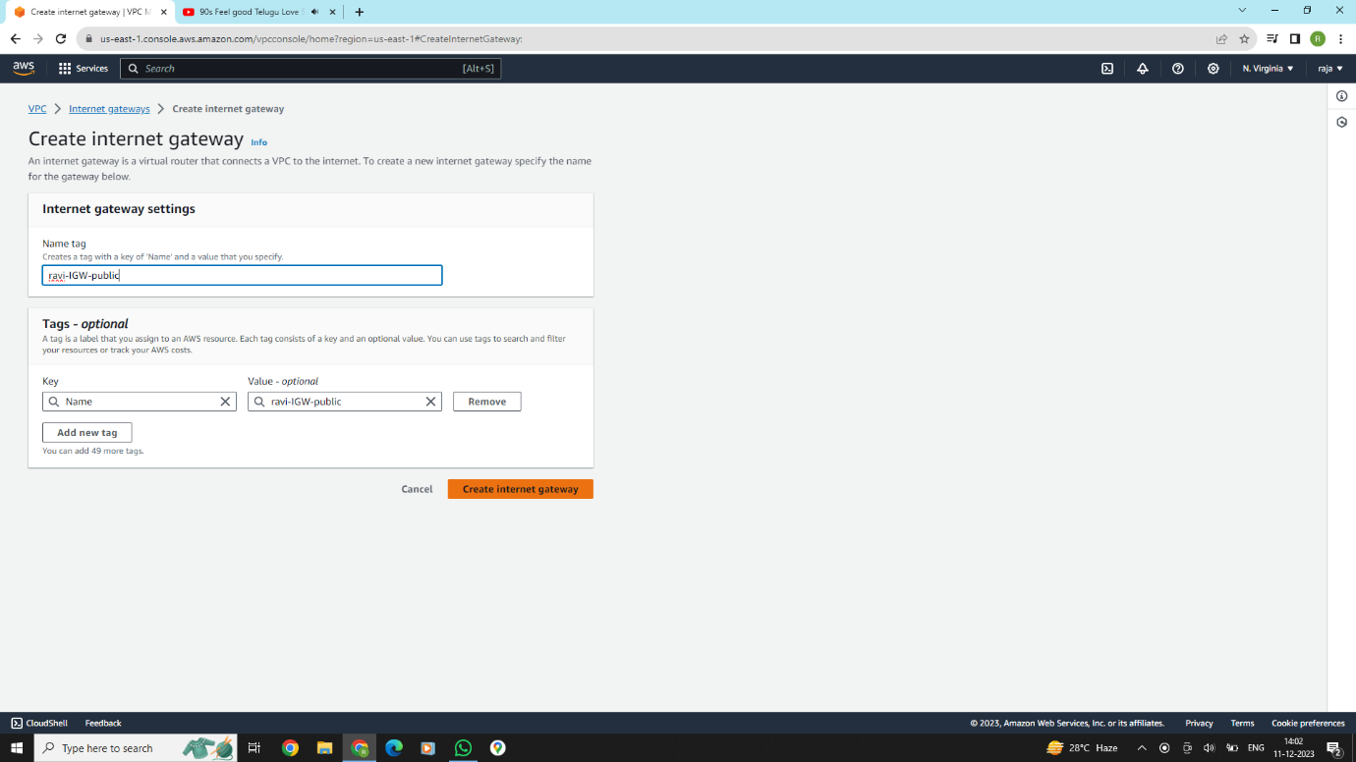

**Here we are adding internet gate-ways to the existing VPC**

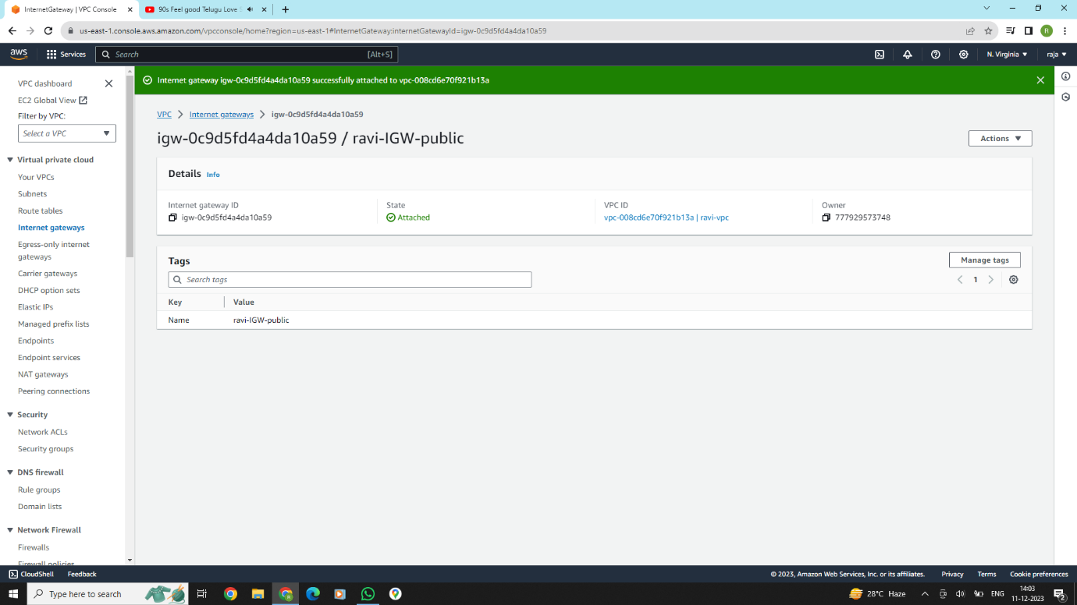

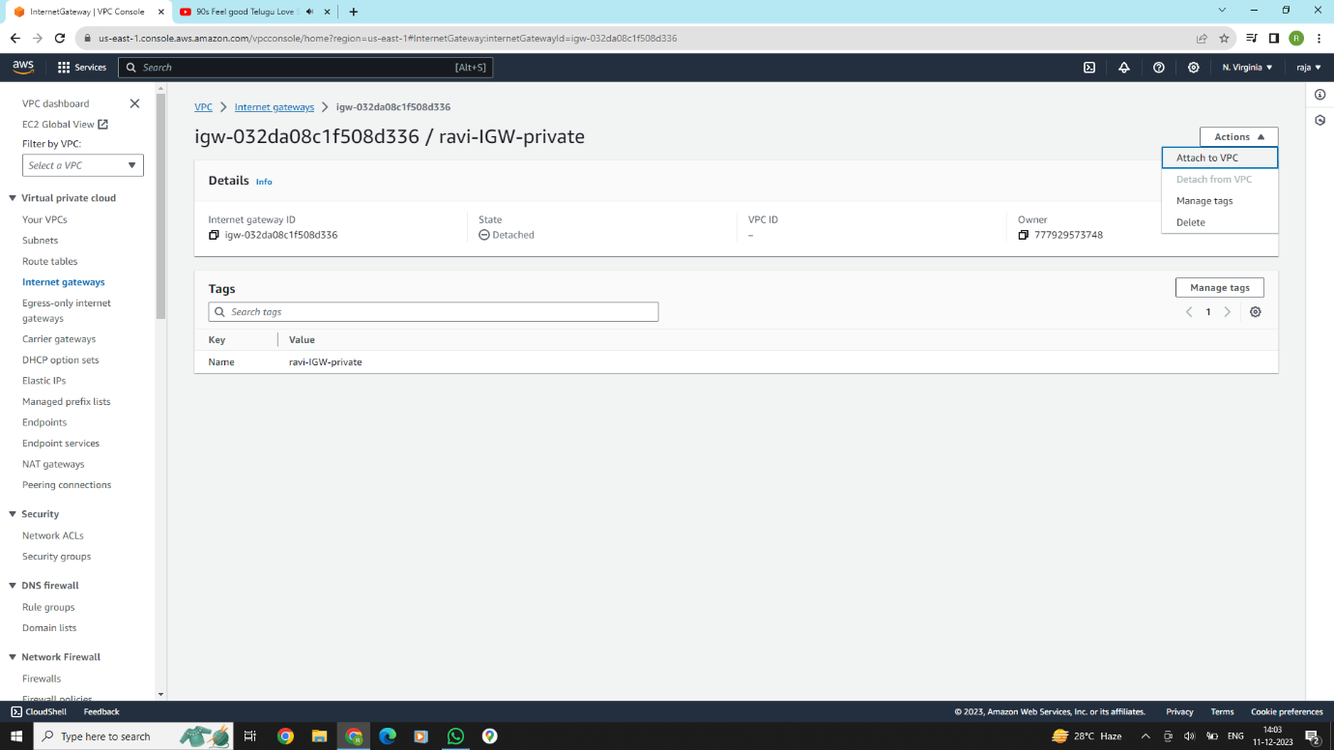

**We are created internet gate-ways successfully in this bellow picture**

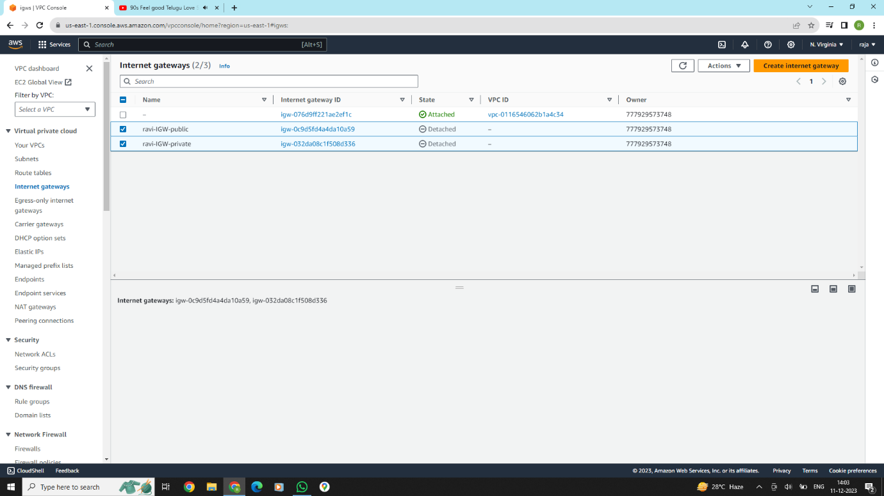

**Create 2 route tables .and attach to the existing internet gate-gateways**

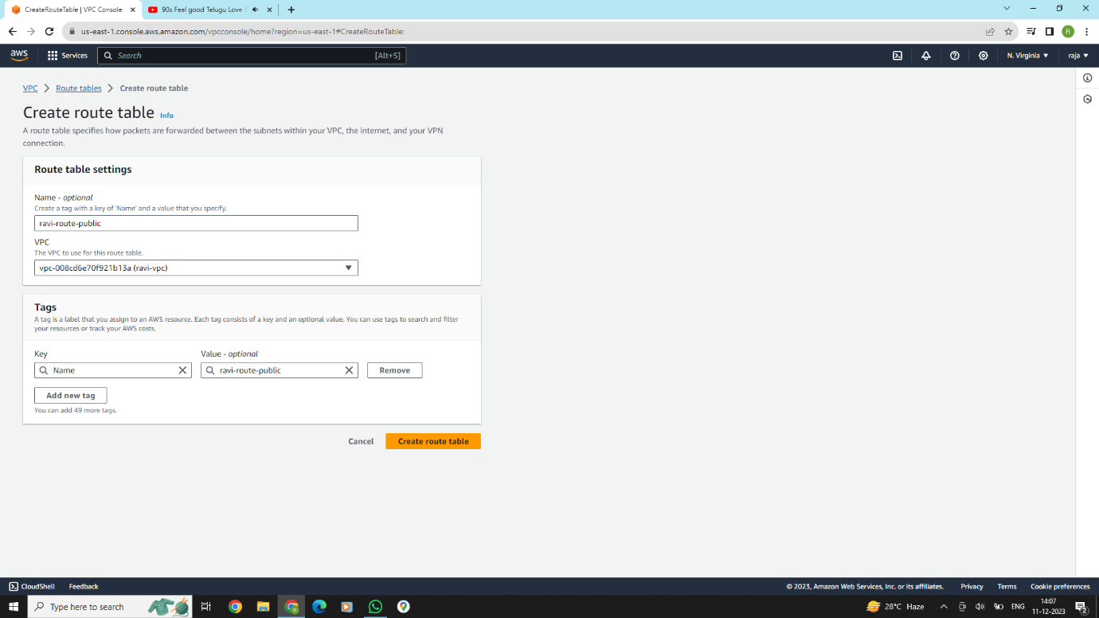

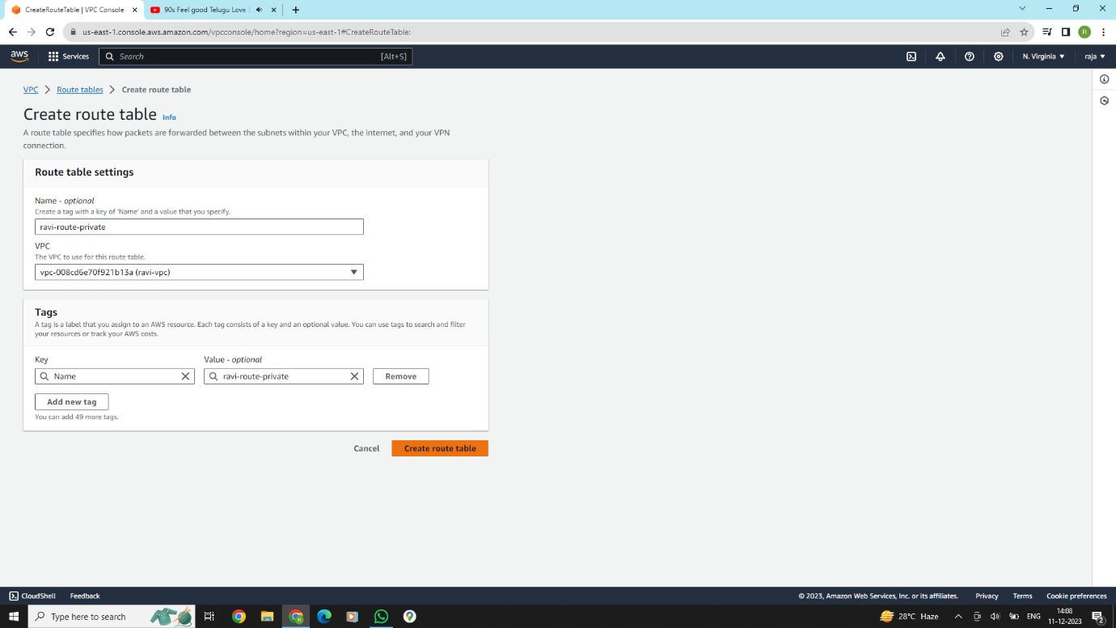

**Public and private subnet route table click the Route tab and add route 0.0.0.0/0 and select the previously created Internet Gateway. next hit the save changes button**

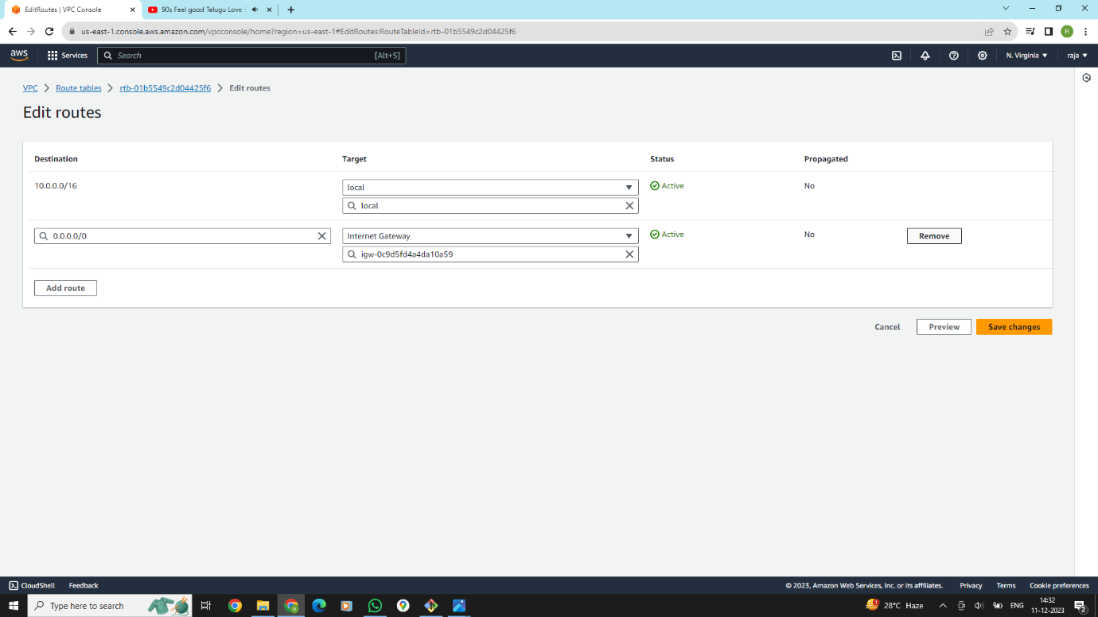

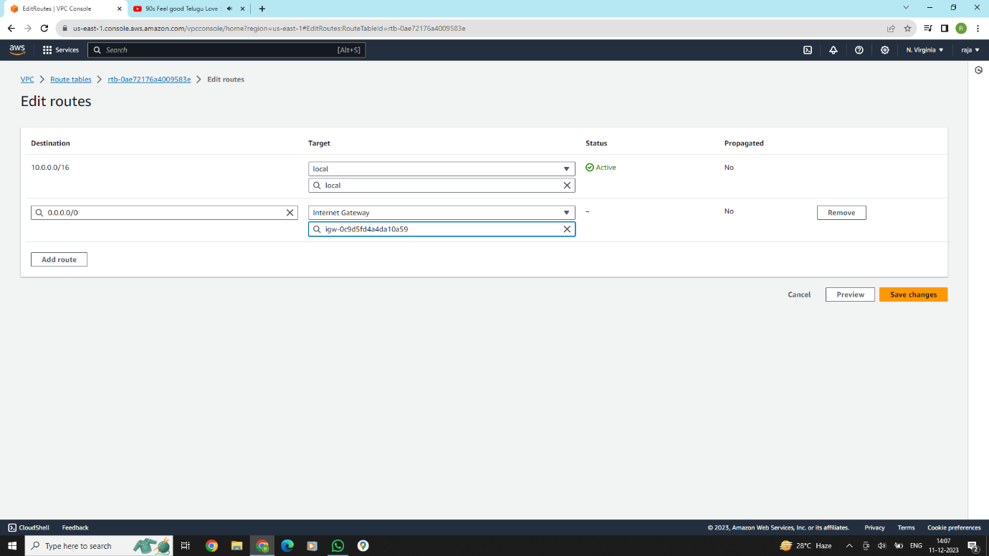

**In the public and private subnets route table click the subnet association section and click edit "Explicit subnet associations" section.**

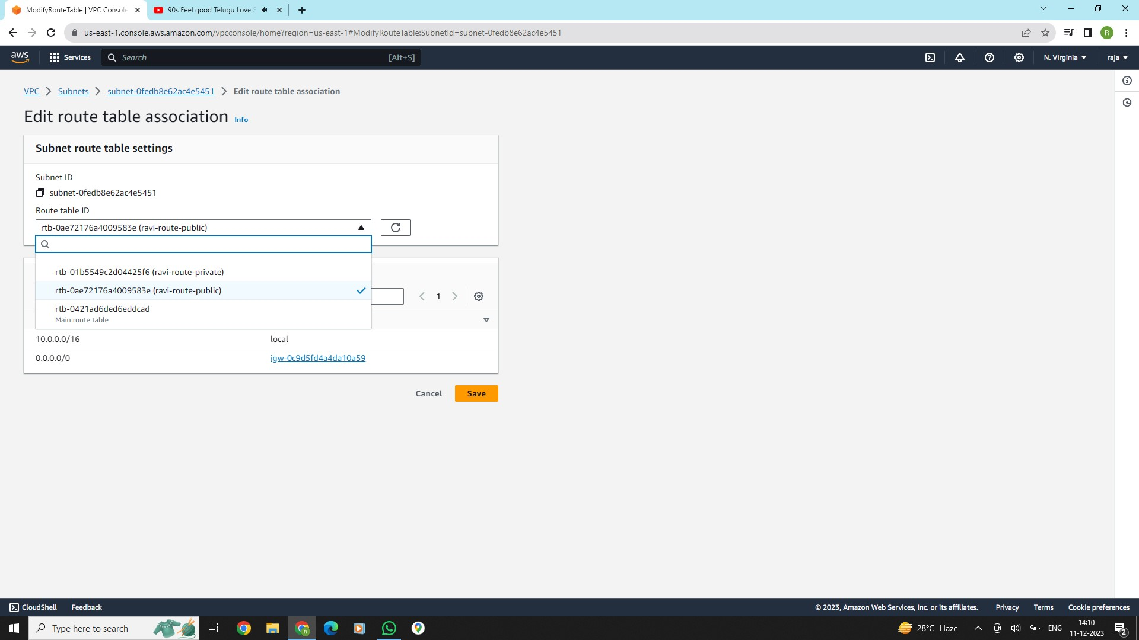

**Now we go to public subnet and click subnet settings and enable "Enable auto-assign public IPv4 address" and click save.**

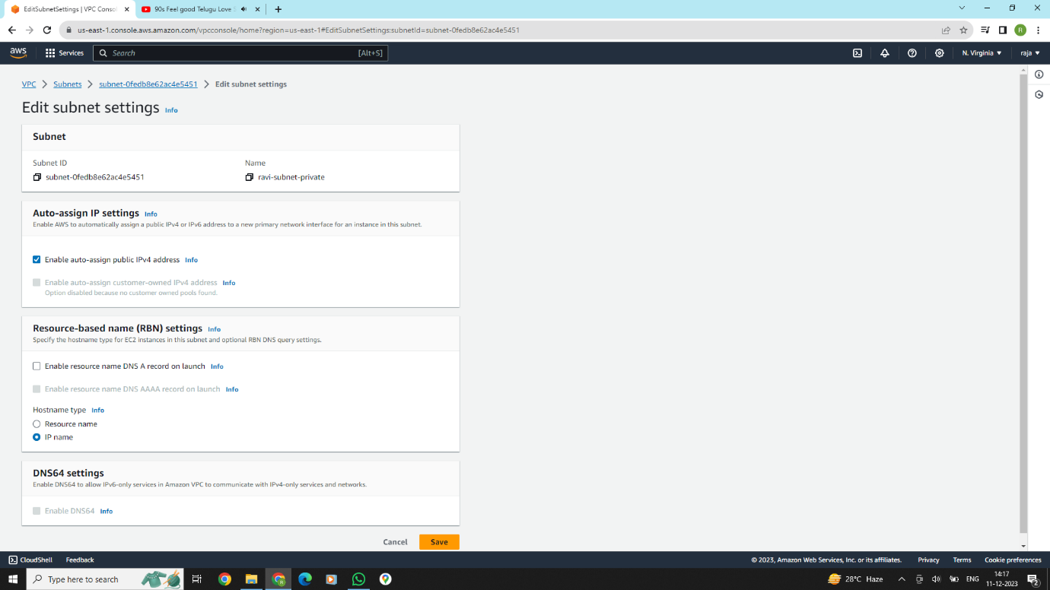

**Go to the VPC console and create NAT Gateway. In NAT gateway creation select subnet as public subnet and give the name for NAT Gateway. After that click Allocate Elastic IP button and finally click create NAT gateway button.**

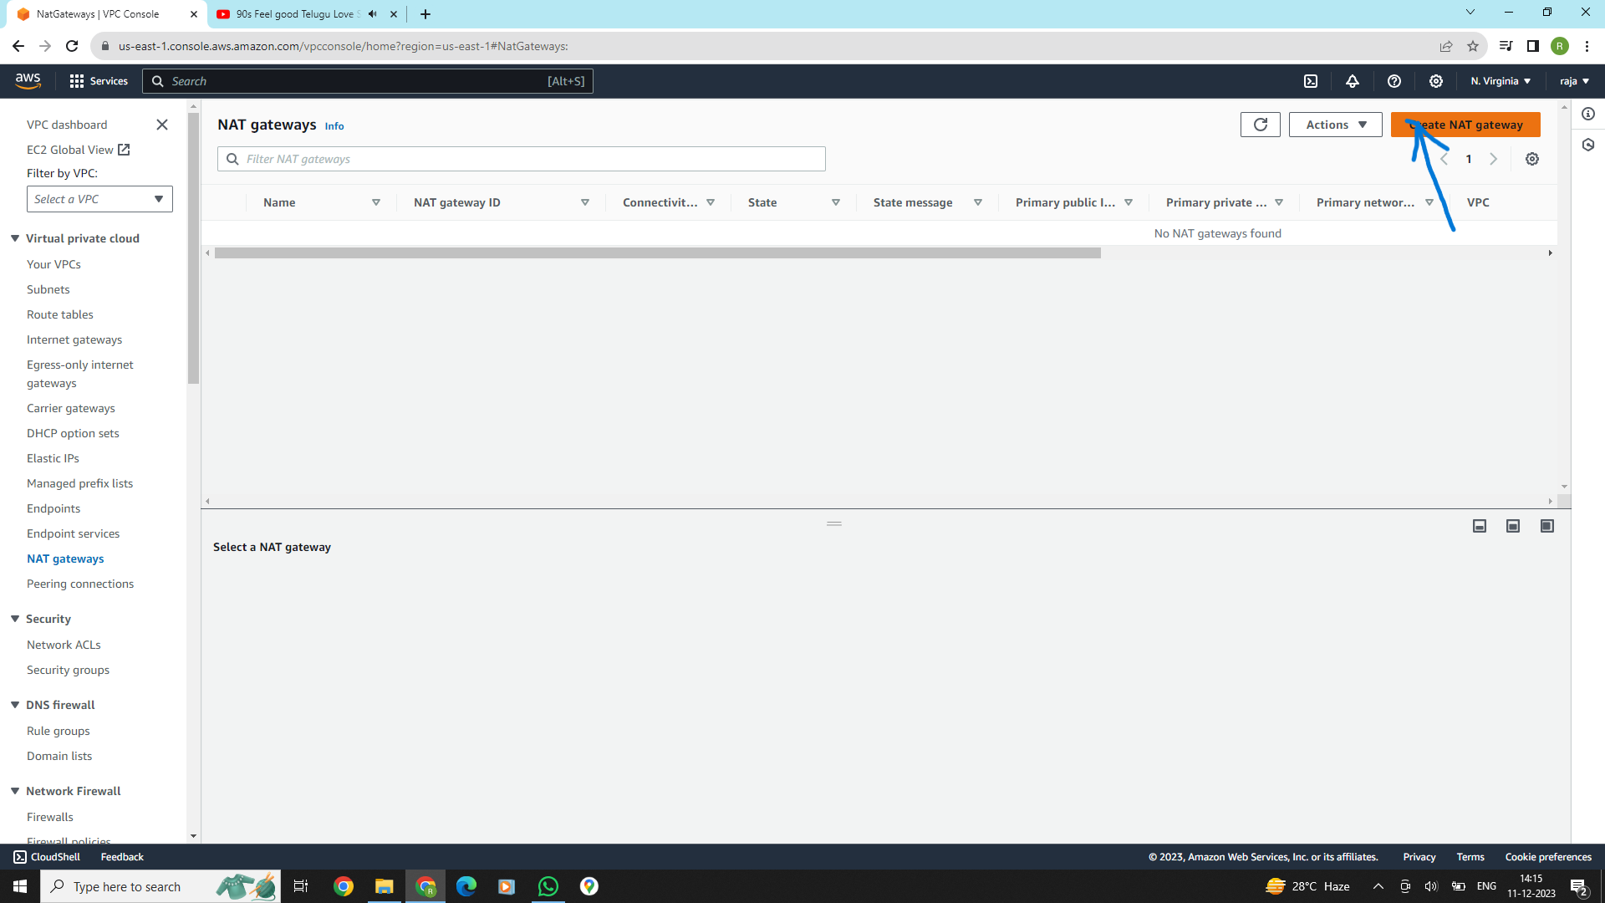

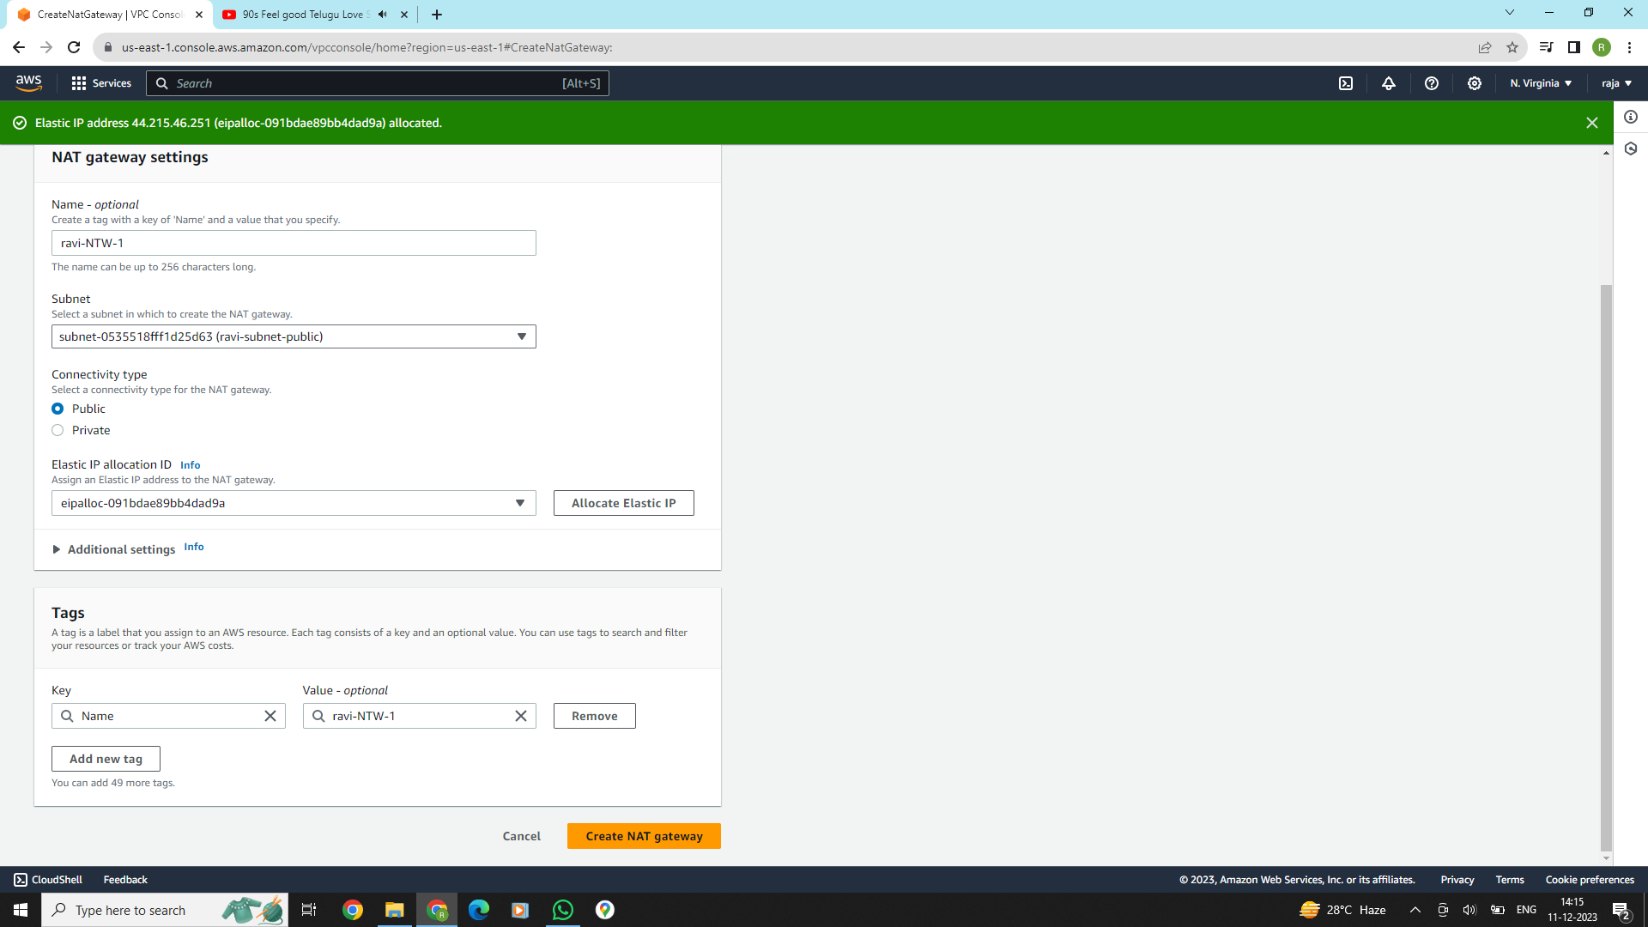

**Next, we want to create 2 ec2 instances inside public and private subnets.**

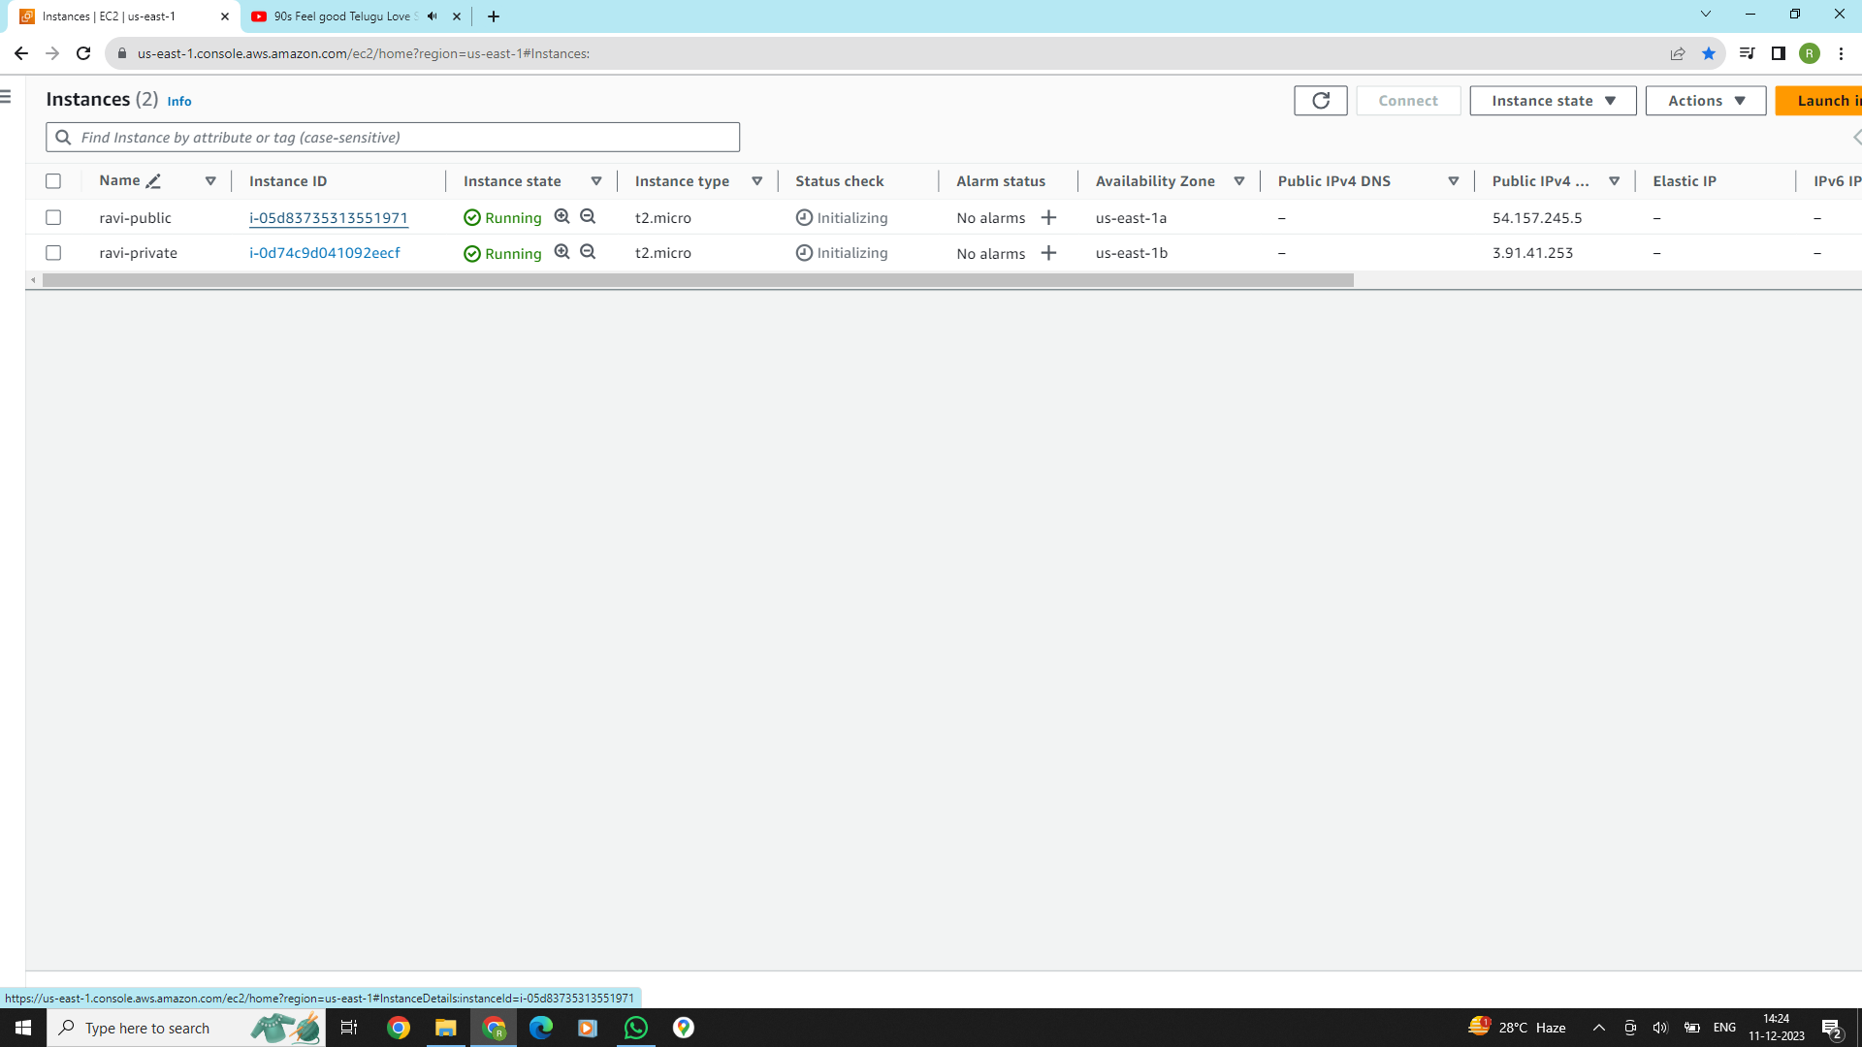

**In the EC2 console click Elastic ip and create ELastic ip like follwing.**

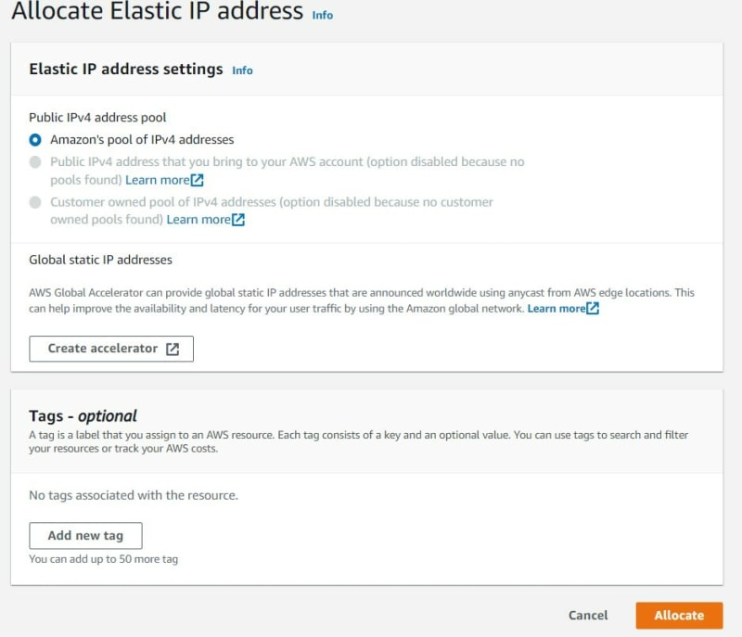

**Connect public EC2 via SSH client or EC2 Instance connect Working it means public ec2 can connect internet.**

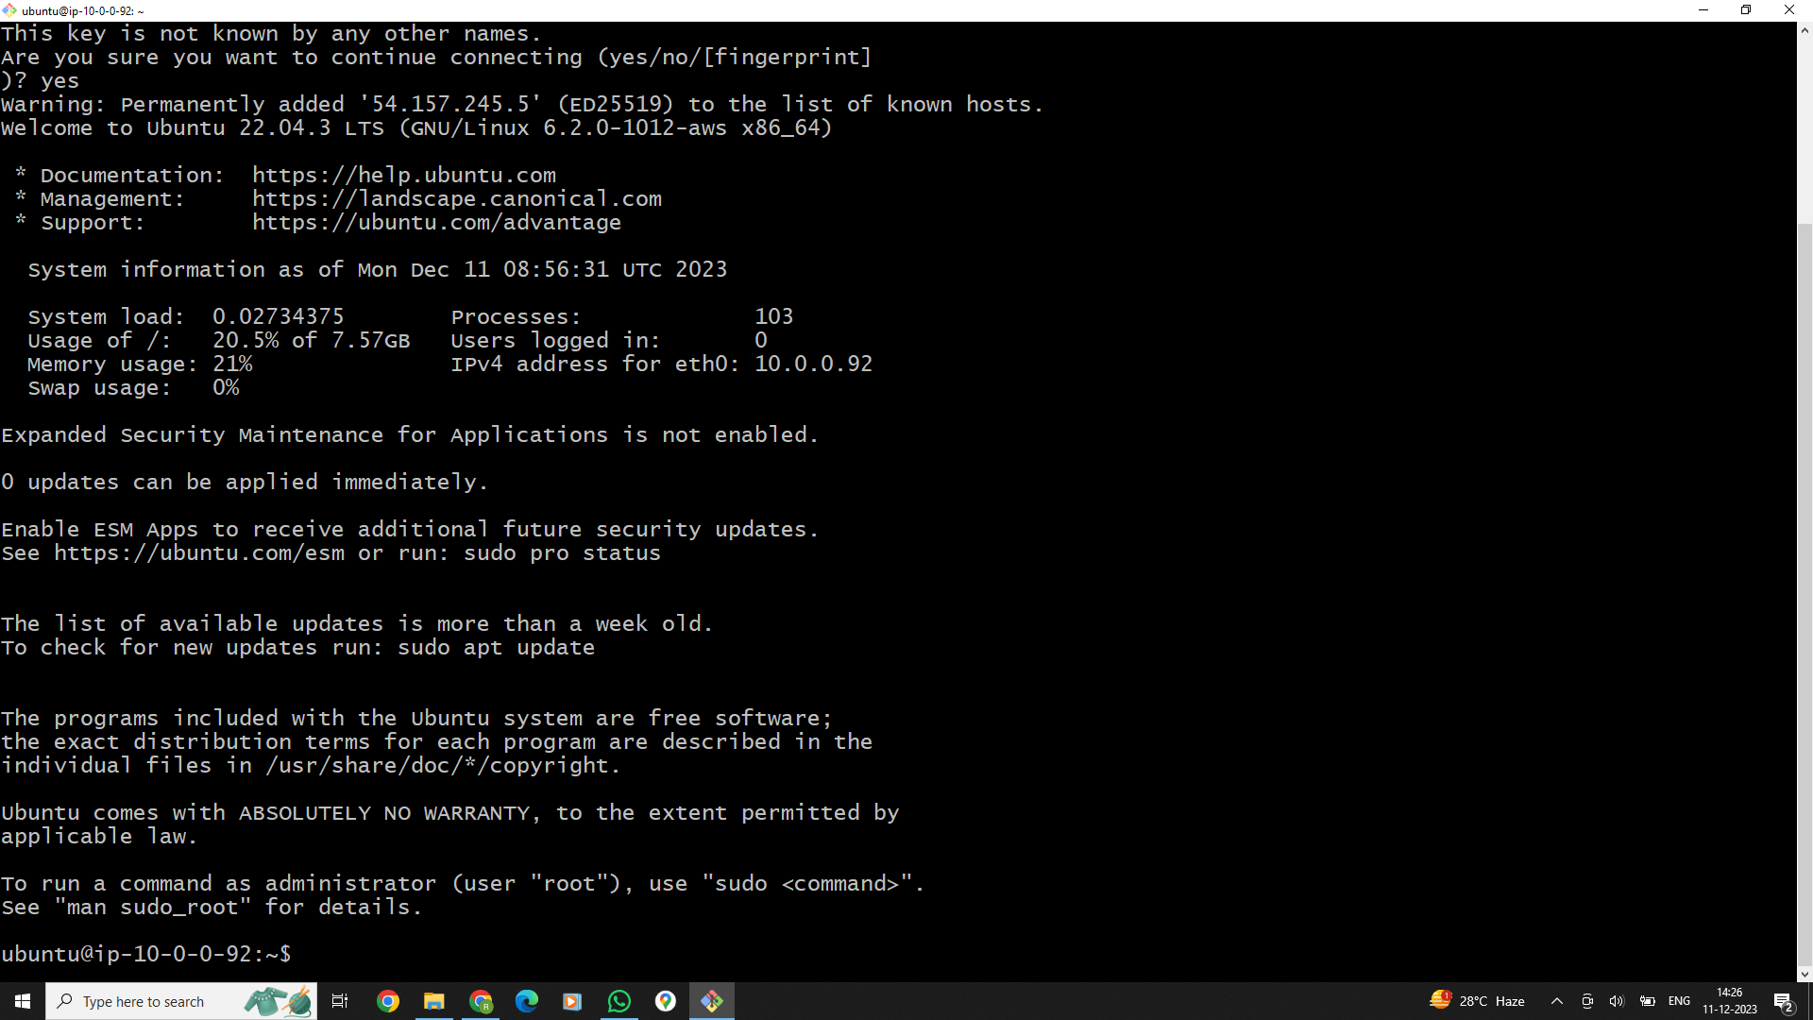

**Now, we try to SSH into EC2 in Private Subnet** **Working it means public ec2 can connect internet.** **try to "ping google.com" inside a private subnet terminal. You can see the following output.**

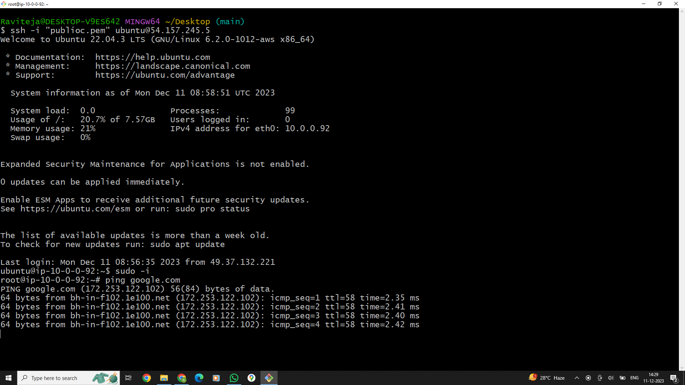

**In this bellow picture we removed internet gate-way to one route table .**

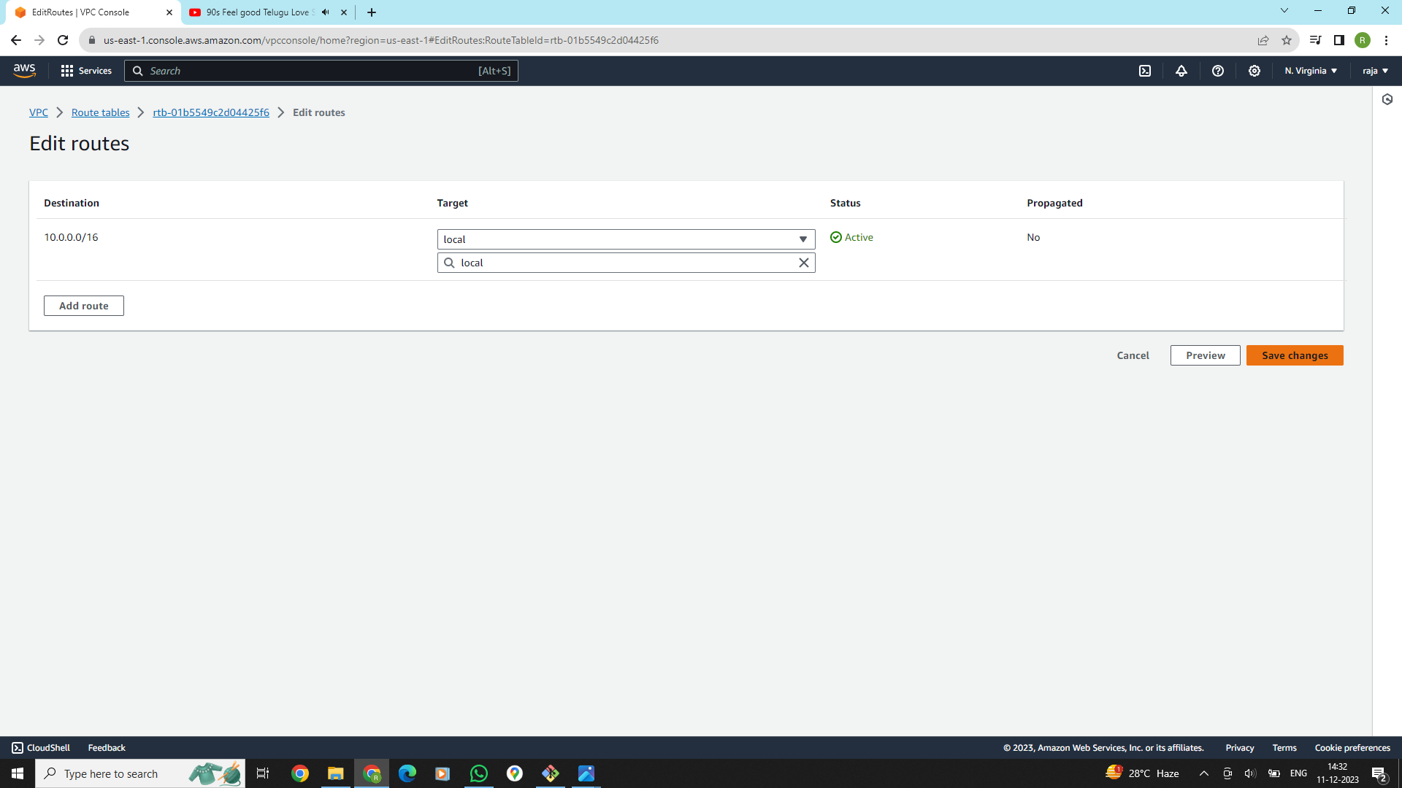

**Now see the instance weather instance will work or not after remove internet gate-way to the route-table Here we can see this instance was not working .**

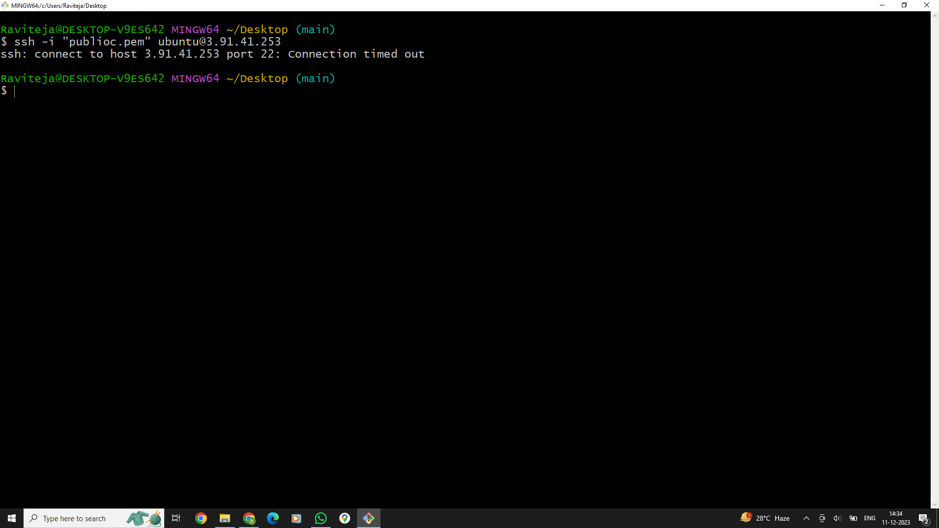

**Next connecting with private ip-address of the above instance in the public instance which is connect with internet gate-way.now create a file in private instance with the pem file, which is having the same file in public instance .Connect with the public instance and login as a root user using command [sudo –i] and connect with ssh link of the private instanceAt this link remove the public ip-address and connect with private ip of private instance working it means public ec2 can connect internet..**

